Cree Outfitting and Tourism Association (COTA)
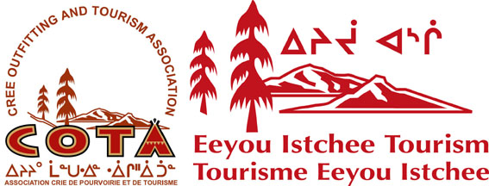
Eeyou Istchee Tourism (EIT)

Your Partners for Tourism in Eeyou Istchee

Membership Application 2019-2020

Member Information Individual Business or organisation

Name:_______________________________________________________________________________
Business/Organization (if applicable): ________________________________________________________
Title (if applicable): _______________________________________________________________________
Address: _____________________________________________________________________________
Community: ________________________ Postal Code: ______________________________________
Telephone: ( ) ____________________ Fax: ( ) __________________________________
Toll Free: ( ) ____________________ Email: _____________________________________
Website: _____________________________________________________________________________

Category that best describes the type of Business/Organization:
Outfitting (hunting, fishing) -------------------------------------------------------
Please provide a copy of your outfitting permit. Copy attached? Yes No
Classification level according to FPQ (if applicable)_______________
Adventure/Eco and Cultural Tourism (snowmobiling, canoeing, etc.)------------
Services (resturants, accomodations, stores, tourism offices, ect.)---------------
Transportation (airplane, helicopter, taxi, boat, ect.)---------------------------------

Active members include:
Any Cree individual or any partnership or organization controlled by a majority of Cree beneficiaries engaged in outfitting or tourism activities within the traditional territory of Eeyou Istchee is eligible for active membership. Partnerships and organizations need to appoint an individual to represent them and notify COTA/EIT of the identity of their representitive. Active members are eligible to vote at member meetings.

Information required for Active Members according to COTA/EIT By-laws
I am interested in becoming an Active Member of COTA/EIT:---------------- Yes No
You are a Cree beneficiary or your organization is controlled by a majority
of registered Cree beneficiaries? ------------------------------------------------------- Yes No

Fees for Active Members:
Individual or Small business (1-5 employees) $150.00
Medium business (6-39 employees) $350.00
Large business (40 employees +) $550.00
Government (band councils and regional organizations) $121.00 + (population X 0.54)
--------------------------------------------------------------------------------------------------------------------------------------------------
Method of payment:

Cheque Money order Purchase order

Amount: _____________
Purchase order #:__________________
GST Exemption #:__________________

Please make cheques and money orders payable to Eeyou Istchee Tourism

By signing this application, you affirm the information provided is true and complete. Please note that member information may be used in COTA/EIT publications such as membership lists, tourism guides and websites.

Signature of applicant: _________________________________ Date: ______________________

Please send completed membership application and payment to:
Eeyou Istchee Tourism
205, Opemiska Meskino, P.O. Box 1167,
Ouje-Bougoumou (Quebec), G0W 3C0
Toll free: 1.888. 268.COTA tel:418.745.2220 fax: 1.418.745.2240
email: admin@creetourism.ca

